
PROJECT REPORT
Project on H2O HERO
Course Name:Tools and Technologies for Internet Programming
Course Code:CSE-3532
Submitted to:Sara Karim
Adjunct Lecturer,Dept. of CSE,IIUC.
Submitted by:
C231525-Tafhima Boshra
C231528 - Iffat Anower Mili Khan
C231534 - Mst. Sadia Islam Tazin

Date of submission:09.07.2025

Contents –

- Introduction
- Objective
- Project Description
- Features
- Flowchart
- Output
- Conclusion
- Future Work

Introduction:
Access to safe drinking water is a fundamental human need. With increasing concerns about water purity and availability in maximum areas of Bangladesh, there is a growing demand for reliable water delivery services. To address this need, the "H2O Hero" website was created — an online platform allowing users to order purified water of varying quantities, track their daily intake, and stay informed, all from the comfort of their homes.

Objectives:
-To develop a responsive and interactive web platform for water delivery.

-To allow users to easily select water types, customize quantity, and place orders.

-To promote water awareness and healthy hydration habits through tracking tools.

-To enhance user experience with a modern design and intuitive interface.

Project Description:
The H2O Hero website is a user-friendly, responsive web application designed to simplify the process of ordering purified water online. It allows users to choose from various water types, adjust quantities with interactive buttons, and view a live cart summary with total pricing. Additionally, the site includes a water intake tracker to promote healthy hydration, a contact form for custom queries, and an embedded Pinterest board to inspire wellness. Built entirely with HTML, CSS, and JavaScript, the project focuses on clean design, ease of use, and essential daily utility without requiring backend support in its current version.

Features:
Key Features:
- Water ordering system (from 500ml to 10,000L)
- Quantity control (+ / - buttons)
- Cart summary with price calculations
- Water intake tracker with motivational messages
- Contact form for custom orders or inquiries
- Pinterest board integration for hydration awareness
- Responsive design for all devices

Technologies Used:
Frontend:
- HTML5: Structure of the website.
- CSS3: Styling, animations, and responsive layout.
- JavaScript: Dynamic functionality (cart, tracking, quantity updates).
- Google Fonts: Custom fonts for branding and design.
- Pinterest Embed: For health inspiration.
Backend:
Backend implemented yet.

Function Descriptions:
- HTML: Structured content like sections, forms, buttons, and cart layout.
- CSS: Designed gradients, cards, responsive layout, shadows, and hover effects.
- JavaScript:
- addToCart(): Adds selected item with price and quantity to cart.
- changeQuantity(): Dynamically updates selected quantity.
- removeItem(): Deletes item from cart and updates total.
- trackWater(): Tracks daily intake and shows suggestions based on input.

Flowchart:
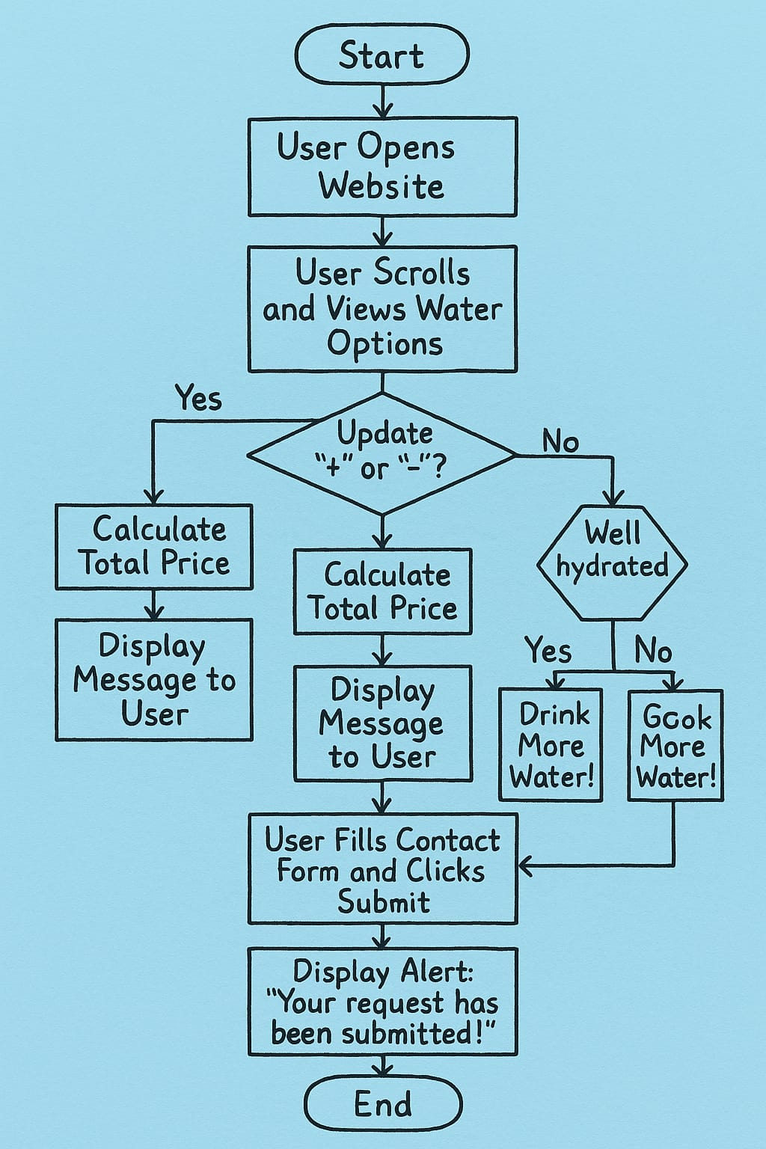

Output:
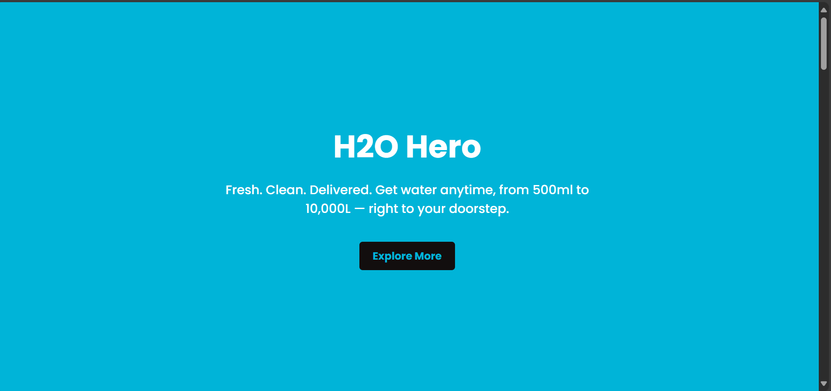
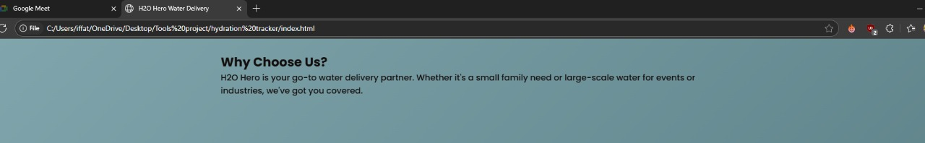
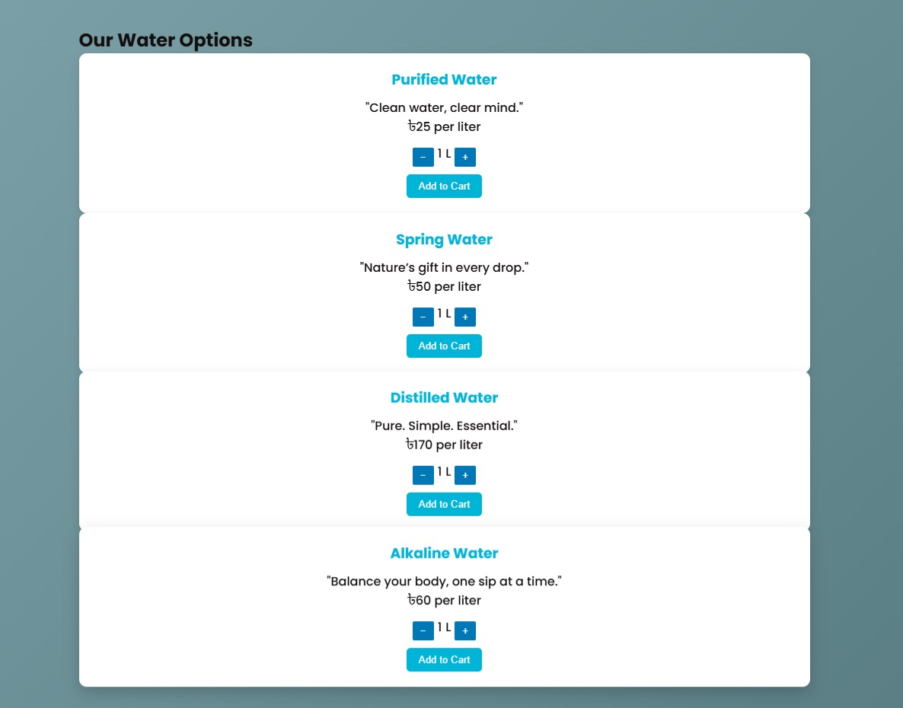
Add cart:
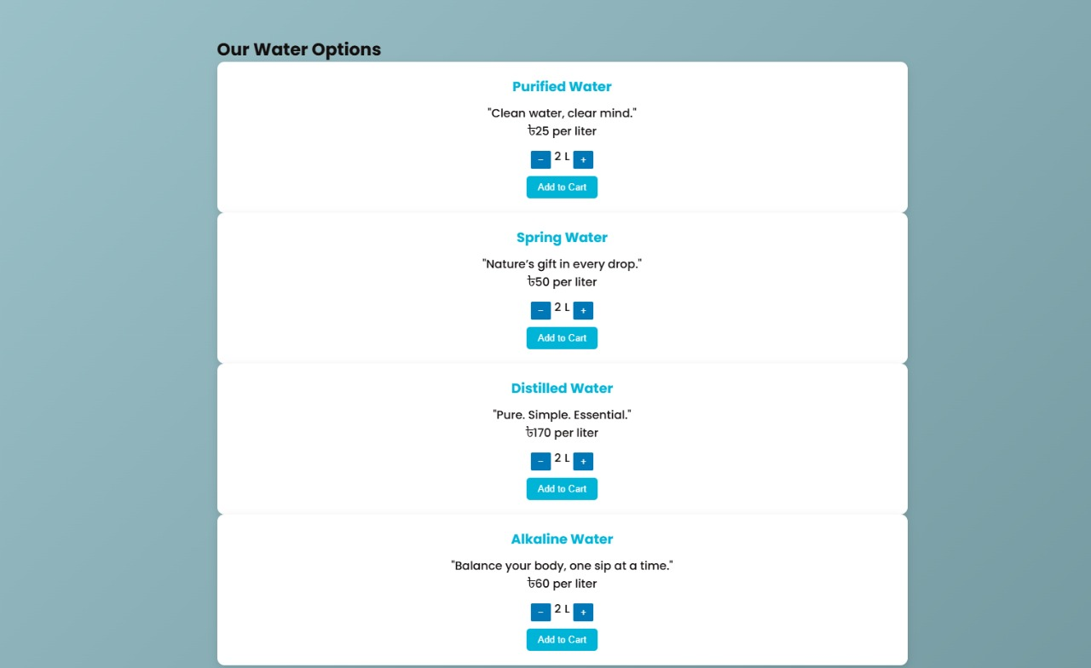
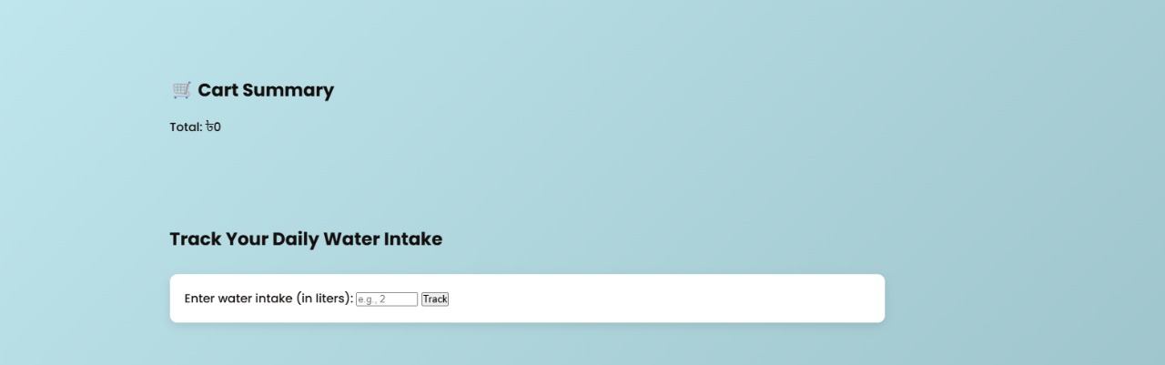
Update cart Summery &water Intake:
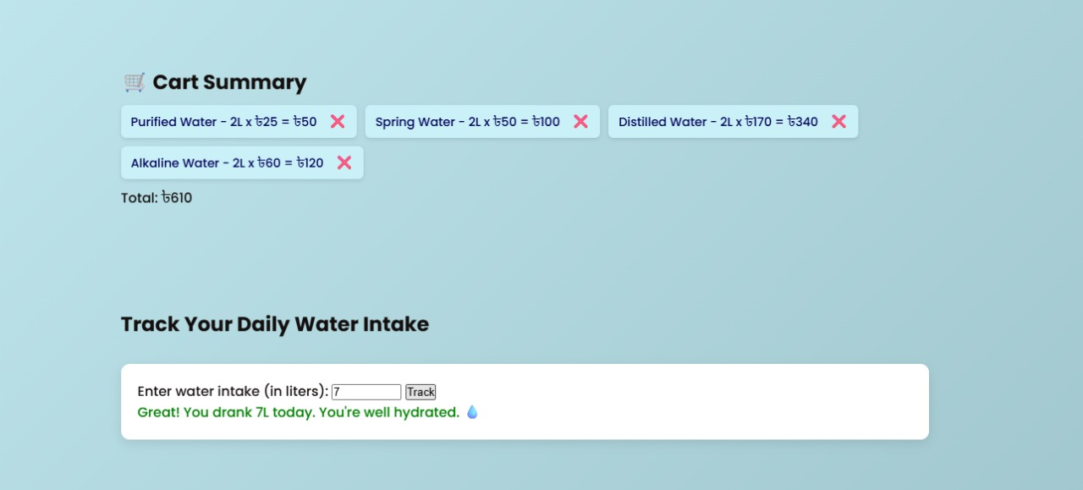
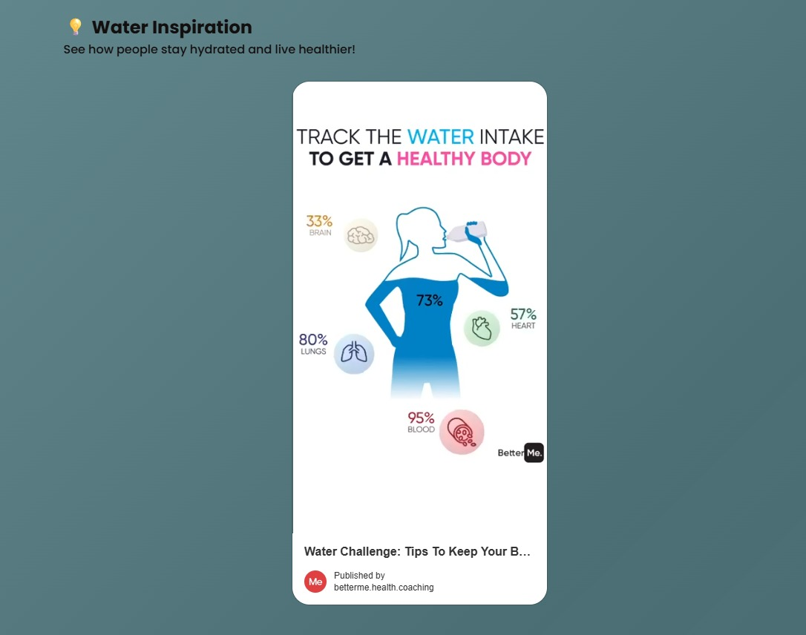
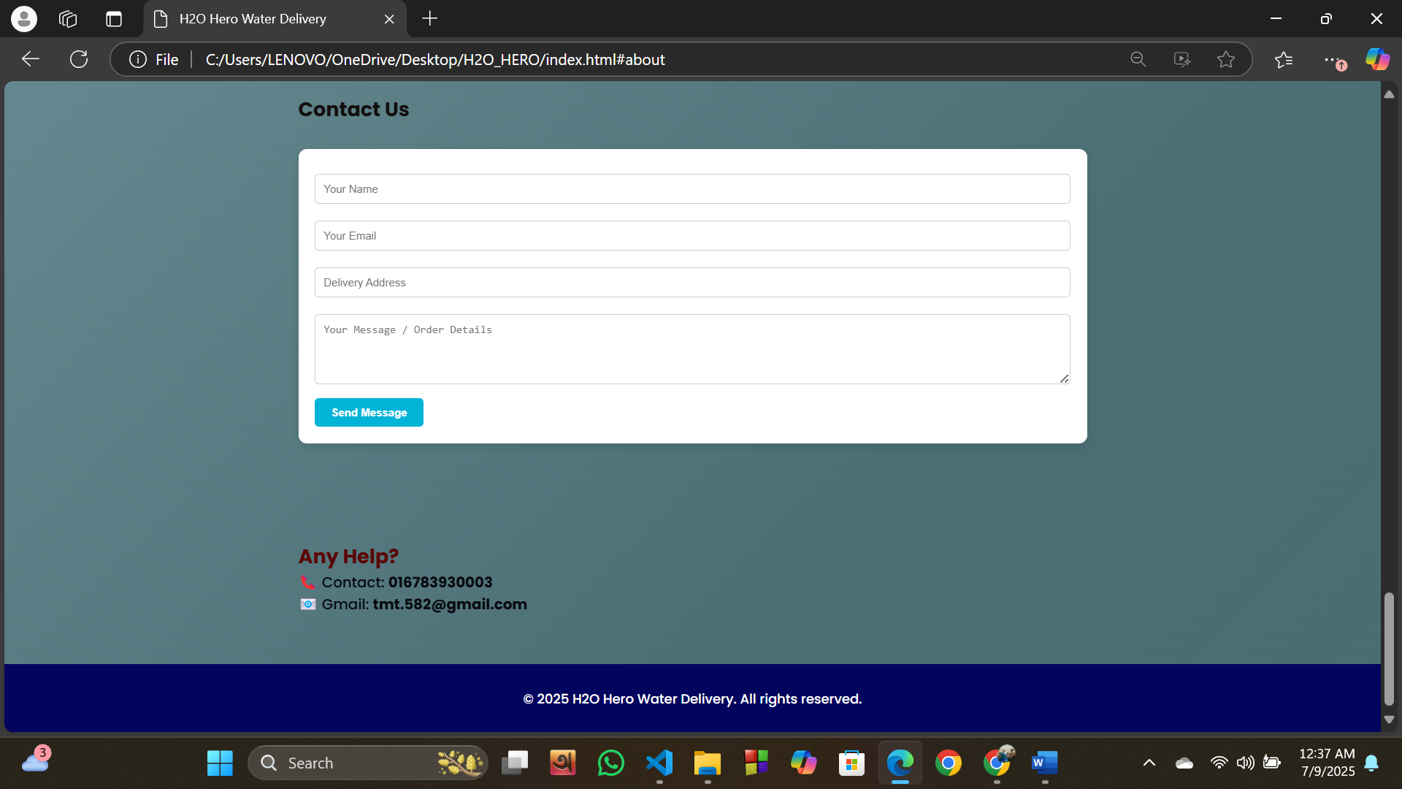
Update Form:
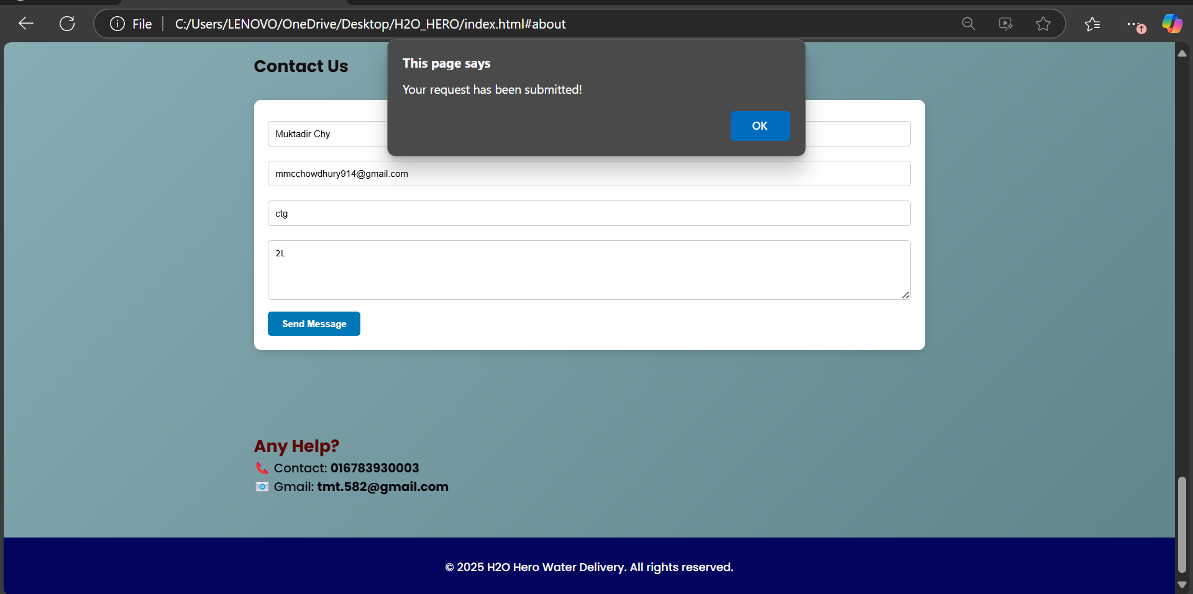
Conclusion:
The H2O Hero Water Delivery Website is a practical solution for urban users to manage their purified water needs effectively. It simplifies the ordering process, encourages healthy hydration habits, and offers an elegant interface. This platform demonstrates the power of modern frontend development for solving real-life problems.

Future Work:
- Develop a full backend using Node.js, Express.js, and MongoDB for real-time order handling.
- Add admin dashboard to manage orders and delivery statuses.
- Enable online payment gateway integration (e.g., bKash, Nagad).
- Introduce user water intake history tracking via local storage or database.
- Create a mobile app version for easier access and push notifications.

End

